**Maths Behind Simple Neural Network**

**Contents:**

*Section 1- Linear Perceptron*

*Section2 – Non-Linear Perceptron*

*Section3- Multi Layer Perceptron*

**Section 1- Linear Perceptron**

Appearance- 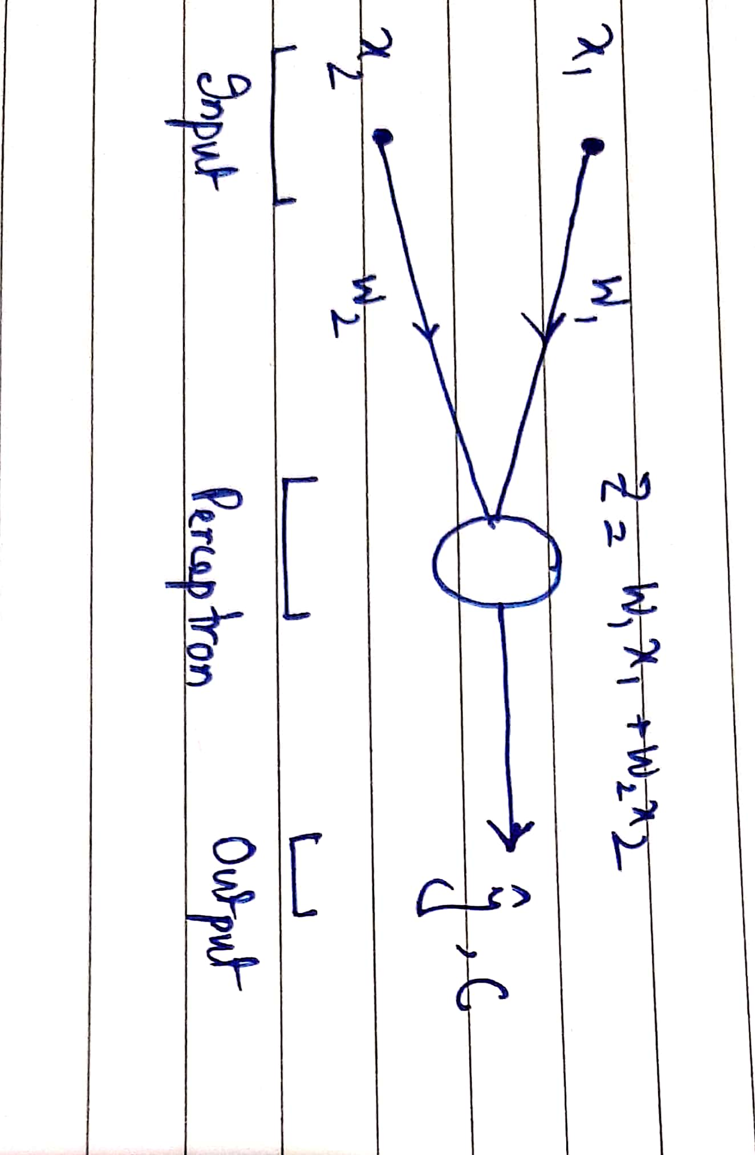

**Math:**

$output= \hat{y}=z$ (1)

$\hat{y}=w_{1}x_{1}+w_{2}x_{2}+b$ (2)

$error=c={\left(\hat{y}-y\right)}^{2}$ (3)

Our aim is to reduce the error. From Eq (3) and Eq (2) shows that error is a function of $w_{1},w_{2}, and b$ as well as inputs x1 and x2.

Among these, only w1 and w2 i.e., weights and b are tuneable parameters, i.e., we can change it as we wish.

Hence, our aim is to change w1 and w2 and b such that error becomes low.

Updating weight-

$w_{i}=w_{i}-α\frac{∂c}{∂w_{i}}$ for i=1,2 (4)

$b=b-α\frac{∂c}{∂b}$ (5)

Let’s calculate $\frac{∂c}{∂w_{i}}$ first

But, c is not directly related to wi

Hence, apply chain rule-

$\frac{∂c}{∂w_{1}}=\frac{∂c}{∂\hat{y}} X \frac{∂\hat{y}}{∂z} X \frac{∂z}{∂w_{1}}$ (6)

1 2 3

Term 1- $\frac{∂c}{∂\hat{y}}=\frac{∂{\left(\hat{y}-y\right)}^{2}}{∂\hat{y}}=2(\hat{y}-y)$ (7)

Term 2- $\frac{∂\hat{y}}{∂z}=\frac{∂z}{∂z}=1$ (8)

Term 3- $\frac{∂z}{∂w_{1}}=\frac{∂(w_{1}x_{1}+w_{2}x_{2}+b)}{∂w_{1}}=x_{1}$ (9)

From Eq (6) and (7), (8) and (9)

$\frac{∂c}{∂w_{1}}=2\left(\hat{y}-y\right)* 1* x_{1}$

$\frac{∂c}{∂w_{1}}=2E* 1* x_{1}$ (10)

Similarly,

$\frac{∂c}{∂w_{2}}=2E* 1* x_{2}$ (11)

$\frac{∂c}{∂b}=2E$ (12)

$w_{i}=w_{i}-α*2E*x_{i}$ for i=1,2 (13)

$b=b-α*2E$ (14)

**Contd. To (Section-1) of**

***single_linear_nonlinear_perceptron.ipynb***

**Section 2- Non-linear Perceptron**

Appearance:

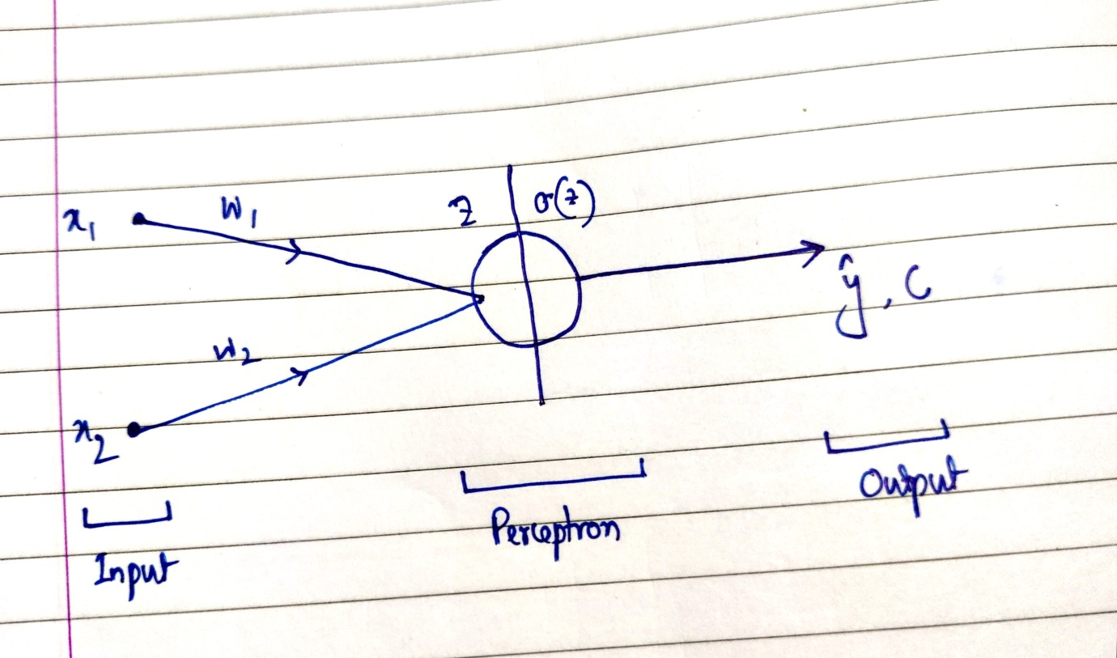

**Math:**

$σ(z)=\left(\frac{1}{1+e^{-z}}\right)$

$\frac{∂c}{∂w_{1}}=\frac{∂c}{∂\hat{y}} X \frac{∂\hat{y}}{∂z} X \frac{∂z}{∂w_{1}}$ (1)

Term 1- $\frac{∂c}{∂\hat{y}}=\frac{∂{\left(\hat{y}-y\right)}^{2}}{∂\hat{y}}=2(\hat{y}-y)$ (2)

Term 2- $\frac{∂\hat{y}}{∂z}=\frac{∂σ(z)}{∂z}=σ'(z)$ (3)

Term 3- $\frac{∂z}{∂w_{1}}=\frac{∂(w_{1}x_{1}+w_{2}x_{2}+b)}{∂w_{1}}=x_{1}$ (4)

From Eq (1) and (2), (3) and (4)

$\frac{∂c}{∂w_{1}}=2\left(\hat{y}-y\right)*σ'(z)* x_{1}$ (5)

$σ^{'}\left(z\right)=\frac{∂σ\left(z\right)}{∂z}=\frac{∂}{∂z}\left(\frac{1}{1+e^{-z}}\right)$

$=\frac{e^{-z}}{{\left(1+e^{-z}\right)}^{2}}=\frac{1}{(1+e^{-z})}x\frac{e^{-z}}{(1+e^{-z})}=σ\left(z\right)*\left(1-σ\left(z\right)\right)$ (6)

Hence, from Eq (5) and (6)

$\frac{∂c}{∂w_{1}}=2\left(\hat{y}-y\right)*σ\left(z\right)*\left(1-σ\left(z\right)\right)* x_{1}$ (7)

$=E*σ\left(z\right)*(1-σ\left(z\right))* x_{1}$

$\frac{∂c}{∂w_{2}}=2\left(\hat{y}-y\right)*σ\left(z\right)*(1-σ\left(z\right))* x_{2}$ (8)

$=E*σ\left(z\right)*(1-σ\left(z\right))* x_{2}$

Hence,

$w_{i}=w_{i}-α\frac{∂c}{∂w_{i}}$

$=w_{i}-α*2E*σ\left(z\right)*\left(1-σ\left(z\right)\right)*x_{i}$ (9)

And,

$b=b-α*2E*σ\left(z\right)*(1-σ\left(z\right))$ (10)

**Contd. To (Section-2) of**

***single_linear_nonlinear_perceptron.ipynb***

**Section 3- Multi-layer Perceptron**

Appearance:

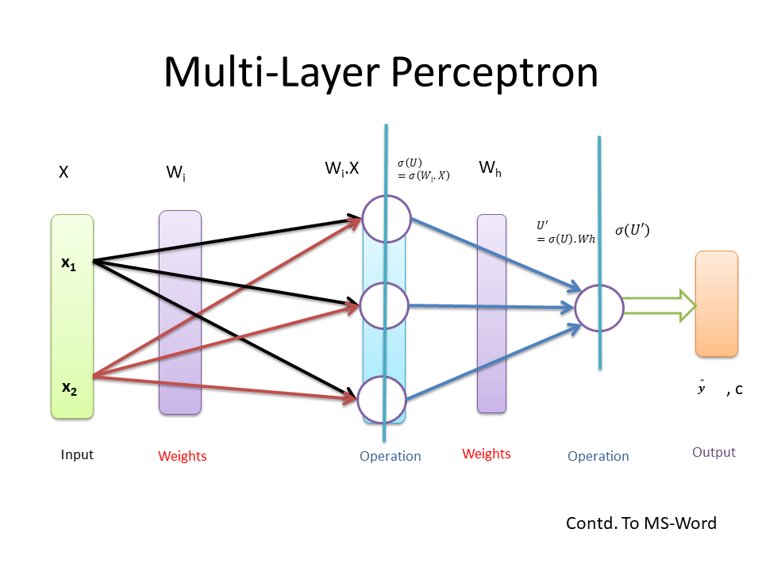

**Math:**

$h=σ\left(u\right)=σ\left(w_{i}x\right)$**(1)**

$\hat{y}=σ\left(u^{'}\right)=σ(w_{h}h)$**(2)**

$c={\left(\hat{y}-y\right)}^{2}$ (3)

$w_{i}=w_{i}-α\frac{∂c}{∂w_{i}}$ (4)

$w_{h}=w_{h}-α\frac{∂c}{∂w_{h}}$ (5)

Now, Let’s calculate $\frac{∂c}{∂w_{h}}$, c is not directly related to wh, so, again Chain Rule

$\frac{∂c}{∂w_{h}}=\frac{∂c}{∂\hat{y}}X\frac{∂\hat{y}}{∂u'}X\frac{∂u'}{∂w_{h}}$ (8)

Individual Terms,

$\frac{∂c}{∂\hat{y}}=(\hat{y}-y)$

$\frac{∂\hat{y}}{∂u'}=\frac{∂σ(u^{'})}{∂u'}=σ\left(u^{'}\right)*\left(1-σ\left(u^{'}\right)\right)=\hat{y}*(1-\hat{y})$

$\frac{∂u'}{∂w_{h}}=\frac{∂(w_{h}h)}{∂w_{h}}=h$

Hence,

$\frac{∂c}{∂w_{h}}=\left(\hat{y}-y\right)*σ\left(u^{'}\right)*\left(1-σ\left(u^{'}\right)\right)*h$ (9)

Now, Let’s calculate $\frac{∂c}{∂w_{i}}$, c is not directly related to wi, so, again Chain Rule

$\frac{∂c}{∂w_{i}}=\frac{∂c}{∂h}X\frac{∂h}{∂u}X\frac{∂u}{∂w_{i}}$ (10)

Again, c is not directly related to h, hence again Chain Rule,

$\frac{∂c}{∂h}=\frac{∂c}{∂\hat{y}}X\frac{∂\hat{y}}{∂u'}X\frac{∂u'}{∂h}$

Hence, from Eq (10),

$\frac{∂c}{∂w_{i}}=\left(\frac{∂c}{∂\hat{y}}X\frac{∂\hat{y}}{∂u^{'}}X\frac{∂u^{'}}{∂h}\right)X(\frac{∂h}{∂u}X\frac{∂u}{∂w_{i}})$

Individual Terms,

$\frac{∂u'}{∂h}=\frac{∂(w_{h}h)}{∂h}=w_{h}$

$\frac{∂h}{∂u}=\frac{∂σ(u)}{∂u}=σ\left(u\right)*(1-σ\left(u\right))$

$\frac{∂u}{∂w_{i}}=\frac{∂(w_{i}x)}{∂w_{i}}=x$

Hence,

$\frac{∂c}{∂w_{i}}=\left(\hat{y}-y\right)*σ\left(u^{'}\right)*\left(1-σ\left(u^{'}\right)\right)*w_{h}*σ\left(u\right)*\left(1-σ\left(u\right)\right)*x$ (11)

Generalized the terms, $\left(\hat{y}-y\right)$ is error or E.

$σ(u^{'})*\left(1-σ\left(u^{'}\right)\right)$ is slope_at_output_layer (SOL)

$σ(u)*\left(1-σ\left(u\right)\right)$ is slope_at_hidden_layer (SHL)

X is input and wh is weight at output layer.

Hence, change factor (delta) at the output layer, dependent on the gradient of error multiplied by the slope of output layer activation= d_out = E*slope_at_output_layer

**Final Anatomy Report**

**Output**

**Hidden**

**Input**

Error w.r.t Wi= Input X d_hidden = SHL X Error_hidden = Wh X d_out = SOL X E

Error w.r.t Wh = Input to output layer X d_out = SOL X E

Or,

(hidden layer activation)

**Contd. To *non_linear_mlp.ipynb***